Darren Bahadoor

8910771

Dr. Fadi Malek

Engineering Computation – Assignment 2

***Question 1***

For this block of code, the numbers 1,2,3,4 will be printed. The while(1) means that the loop will be looped forever until a break function is implemented. In this case, if the integer I is greater than 3, then the loop will stop.

***Question 2***

For this block of code, the code will print the integer 4,3,2,1 and will stop there because when int = 0 and the loop(i) = loop(0) then the code will not execute anything inside the condition because 0 is considered false.

***Question 3 – Programming 5 steps***

***Step 1 – Problem identification and definition***

A program must be created that takes values related to a chart of colors. The two first colors correspond to the two significant digits while the 3rd corresponds to a multiple of base 10 to some exponent. The last number corresponds to the resistance tolerance which can either be gold or silver (5% and 10% respectively). Furthermore, the program must consist of three sub menus called “Resistance calculator”, “Help”, and “Exit”.

***Step 2 – Gathering information and I/O description***

When the program starts, the user must input an integer from 1-3 that corresponds to the menu. If they put “1”, this will correspond to the resistance calculator. The resistance calculator will then ask the user to input 4 integers that correspond to a set of colors. If the user inputs an integer out of the range of the colors, then the user will be prompt to re-enter a number within the range for that specific resistance color. At the end, the program will calculate the resistance and output the value on the screen.

***Step 3 – Algorithm development and verification***

The 1st integer that the user prompts refers to the color of the band. This color will determine the first significant digit of the resistance. The 2nd integer refers again to the 2nd color band which will determine the 2nd significant digit. The 3rd number will be the exponent to a base 10 multiple of the first 2 significant digits combined. The last integer will determine the tolerance which can either be 10% or 5%.

***Step 4 – Implementation***

Refer to code created.

***Step 5*** – ***Software testing and verification***

|  |  |  |  |  |
| --- | --- | --- | --- | --- |
| Color 1 | Color 2 | Color 3 | Color 4 | Total resistance |
| Brown | Black | Brown | Gold | 100 + or – 5% KiloOhms |
| Red | Black | Red | Silver | 2000 + or – 10% KiloOhms |
| Red | Orange | Yellow | Gold | 230000 + or – 5% KiloOhms |

Test 1

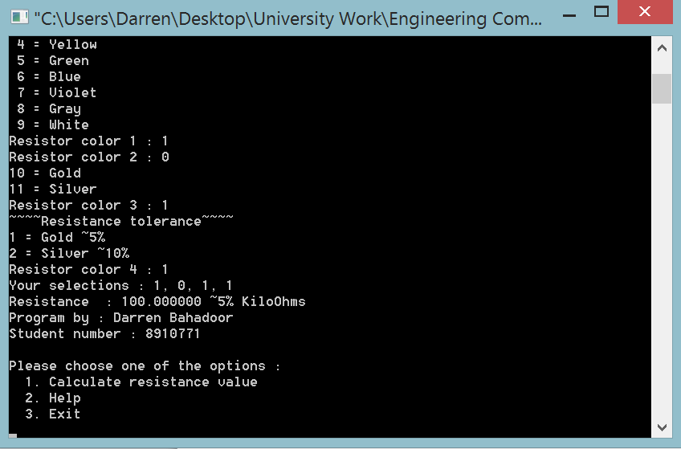

Test 2

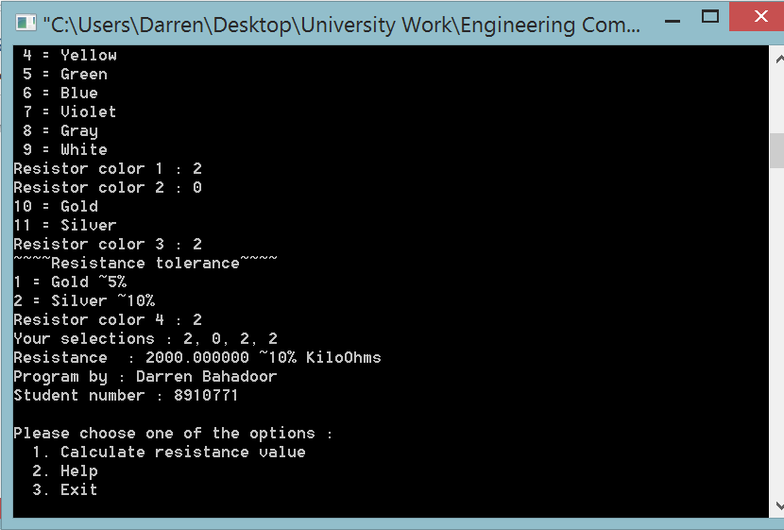

Test 3

